College of Computing

Computer Science Department

CS3141 Team Software Project

Spring 2022

**Project Title**

Section: R01

Team #: 4

| Roll # | Name | Role |
| --- | --- | --- |
| 8 | Avery Doherty | Scrum Master |
| 10 | Brendan Fuhrman | Developer |
| 9 | Nicky Franklin | Developer |
| 6 | Julianna Cummings | Developer |
| 7 | River Dallas | Developer |

Instructor:

Serein AL-Ratrout

# **Abstract**

(***Abstract*** *is one-paragraph summarizes your project, describes the content and scope of the project objective, methodology, findings, and conclusion. So, you need to write one-paragraph that gives an abstract idea about the entire project, the aim of the project, the process model you used, the tools, what you have done, the results, and your conclusion. If you think the project is worth extending to a Final Year Project (FYP) by you or other students or can be adopted and extended by industry/market, then mention that here and add it also as future work.)*

Example of abstract

In this project a student registration web application for university students and staff was developed, the aim of this application is to provide a simple set-up of programs for student enrolment, improve efficiencies and eliminate unnecessary paperwork. The system mainly has two modules: students and staffs. Students can create account then sign in/out, add, update, delete, and modify their data and schedule. Staff can also create account and then sign in, add, update, delete, and modify their data. Waterfall process model followed during project development and the implementation was realized by use of object-oriented PHP, HTML, MYSQL and Dreamweaver technologies.

It has been found that the final system was simple and user friendly with easy user interface, hence the end-users do not need to undergo extensive training or require any special skills. It was also secure, and reliable.

____________________________________________________________________________

____________________________________________________________________________

____________________________________________________________________________

____________________________________________________________________________

____________________________________________________________________________

____________________________________________________________________________

# **Table of Contents**

# **Table of Figures**

Chapter1

Specification

# **1.1 Introduction**

* Project introduction and description:

The star finder website is a website that is supposed to help the user find the stars that are in the night sky. The location of a star can be found by using the user’s longitude and latitude and by using a star's right ascension and declination which we conveniently have in a book. Some of the issues that we may have in doing this project are that we have to find the equations that are used to find stars and that some of our group members have not used one or more of the technologies that we will be using. The purpose of this website is to have the user be able to find where a star is located in the night sky. The motivation behind this project is that stars and astronomy are cool and we want to make it accessible for everyone as well as learn some stuff for ourselves.

# **1.2 Problem Statement**

* Problem statement

The problem with finding stars is that they take complex equations to find their location. To begin, a starting location is needed in which the longitude and latitude coordinates are required. With these numbers, a set of long, complex equations are needed to find the star’s location in which mistakes are inevitable. This problem needs to be solved because without convenient software that can pinpoint the position of stars it is difficult for one to find them through the equations alone.

# **1.3 Aim and Objectives**

The aim of this project is to develop a web application that will look up stars and deepspace objects in the night sky and then tell/show the user where it is in the night sky in a way that is faster and easier than calculating the positions of the stars and objects by hand. This would save a lot of time for people looking up where stars are and would offer an easier barrier of entry to people who are interested in astronomy. We hope to make an easy to use website that utilizes a database that has stars and their information in it.

Objectives:

* To calculate accurate positions of stars in the night sky
* To make a functional website
* To utilize a safe and secure database
* To Display the positions of stars on the website
* To make it easy and fast to look up new stars

# **1.4 Stakeholders**

The members of the team and the CS4711 students are stakeholders.

# **1.5** Methodology

We are using the scrum software process in this project. In scrum we first decide the features that we need to add to the project. We then prepare for a sprint by having a meeting on what we want to work on during the sprint. Once we have determined the features to be implemented in the sprint, we then commit to the sprint and implement those features. During our two week sprint, we will have daily meetings to inform eachother about the progress we are making in the project. We then finish the sprint and have a version of our work that we then demonstrate and get feedback on. We then have a meeting discussing the sprint and update the project backlog if need be. Finally we start planning the next sprint and go until the project is finished.

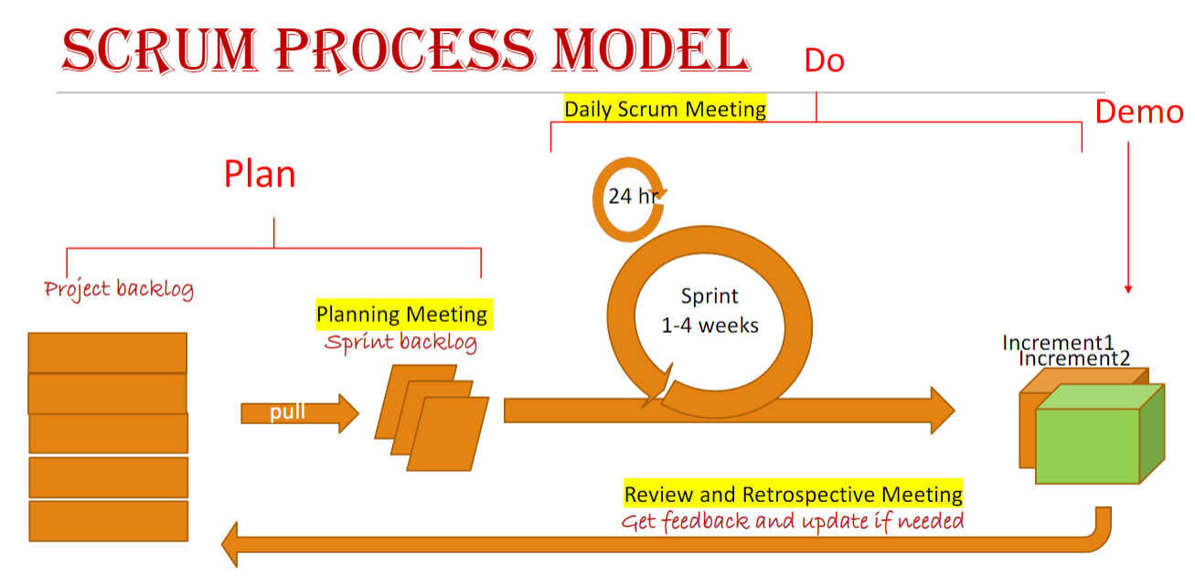

# **1.6 Tools**

Jira, VScode, mySQL, github, html, css, php

# **1.7 High-Level Business Requirements**

## **Functional Requirements**

* A user shall be able to look up a star and get the coordinates of the star
* A user shall be able to log into an account
* A user shall be able to sign up for an account
* A user shall be able to add stars
* A user shall be able sign out of an account

## **Non-functional requirements**

* The website should be available at all hours of the day
* The database should be secure from potential sql injection
* The passwords for users should be protected
* The website should be user friendly enough that someone who has never used the website before can navigate it with ease

# **1.8 Product backlog**

| **Priority** | **User Story** | **Tasks** | **Estimated effort** | **Sprint** |
| --- | --- | --- | --- | --- |
| 1 | **As a user, I want to look up the coordinates of a star in the night sky so I can look at them** | **Design and implement the database for deep space objects** | **3 H** | **1** |
| **Design and implement a prototype website** | **4 H** |
| **Design and implement the star finding equation** | **2 H** |
| **2** | **As a user, I want to log in to my account and save stars so that I can look at them in the future** | **Design and implement a user table in the database** | **1 H** | **2** |
| **Add a secure way to log into an account** | **1 H** |
| **Design a portion of the database where users can keep the stars they want to track** | **1 H** |
| **2** | **As a user, I want to keep track of specific objects that may not be programmed in the database so that I can view custom objects** | **Design a table in the database that will keep track of custom stars** | **2H** | **3** |
| **Update the user table to include a custom list of stars** | **1H** |
| **Update the website to allow the user to view their custom stars** | **3H** |
| **3** | **As a user I want to see the most prominent stars that are out in the sky so that I can see easy to see stars** | **Update the website to include a table of prominent stars**  **________________**  **Implement an algorithm that determines which prominent stars are available to be seen** | **2H**  **1.5H** | **3** |
| **2** | **As a user, I want to see where the planets are in the sky so that I can see where they are** | **Update the Database to include a new category for planets**  **______________**  **Update the website to include an area to view planets**  **_______________**  **Implement a planet coordinate finding algorithm** | **1H**  **1H**  **4H** | **2** |
| **4** | **As a user, I want the raw data that is available about my star so that I can learn more about them** | **Update the database to include the appropriate information for each star**  **_______________**  **Update the website to show the information about a star** | **3H**  **2H** | **3** |
| **3** | **As a user, I want to add stars to the database so that I can add more stars to look at** | **Update the database to have a table that shows potential stars to be added**  **_______________**  **Update the website and database to make certain users admin users**  **_______________**  **Update the website to make it so admin users can easily add stars to the database**  **_______________ Update the database to allow for automatic star insertion** | **1H**  **1H**  **2H**  **1H** | **4** |
| **4** | **As a user, I want to look at a random star in the night sky so that I can have a surprise to find in the sky** | **Update the website to include a random star button**  **________________**  **Develop an algorithm to ensure that a given star will be possible to view in the night sky** | **1H**  **1H** | **4** |
| **4** | **As a user, I want a light mode and a dark mode on the website so that my eyes don’t get irritated whenever I enter the website at night** | **Update the website to allow for a dark mode** | **2H** | **4** |

Chapter 2

Analysis and Design

Chapter 3

Implementation

The following [report](http://people.uncw.edu/simmondsd/documents/450_Implementation%20and%20Testing%20Report.pdf) is a good example that you can follow for implementation please refer to pages 25 - 30, and here is another [example](http://api.uofk.edu:8080/api/core/bitstreams/13308397-e07c-47ef-83e5-3bbb2e9f0a81/content) for your reference.

Chapter 4

## Validation

**For Chapter 4 (Validation)**: here you need to write about the process of checking that your software system meets specifications and requirements so that it fulfils its intended purpose, and to confirm or to prove the accuracy of your project.

Write about your testing and validation; **level of testing** you had, unit testing, integration testing, validation testing and acceptance testing.   Did you have **manual or automated** testing or both? specify the part(s) that have automated testing and part(s) that have manual testing, and **What is your oracle?**

**Write the** **test cases** for valid and invalid **input** (please see Week3 Automated Testing/ slide 11),

then confirm that no errors in the code and the application is able to operate in required condition (OS, web browsers) and you have created the code correctly.

For validation and acceptance testing write who tested your system? MTU students? computer science student? other department students? your group only? other college students? public users? How many students/users? How many times? could they use it easily or did they make mistakes?

Chapter 5

## Limitations and Future Work

**For Chapter 5**

Limitations: address everything that the project left,  if some project backlog items/ features/ requirements have not been implemented then mention them in this part with an explanation/justification why you couldn't implement them (Time constraints the time was not enough, some developers were unavailable, because of COVID19, or  tool limitation ....etc.). Many students tend to feel that presenting the limits of their work makes work weaker. on the contrary, approaching this section shows maturity for the academic universe, and writing about them actually strengthens your work by identifying any problems before reviewers/readers find them.

Future work : if the limitations can be addressed in the future then add this in here in future work, moreover, if you believe this project can be extendable (add more features/ more parts) that the project is worth extending to a Final Year Project (FYP) by you or other students or can be adopted and extended by industry as a product so you can give directions for that in future work.

Chapter 6

Conclusion

**For  Chapter 6 (Conclusion),**: write what you have concluded.

Examples:

I solved many problems in the project…

This application/project/system was applied to improve the learning process.

The results of this project showed that system significantly facilitated the students' learning process.

The system is useless, acceptable, usable, beneficial or maybe enjoyable and why do you believe that.

References

(Include any references to external documents or materials (for example, tutorials the team will be using, literature , web references or links to documentation of third-party tools you will use) here.

The references should be properly numbered and correctly used in the text.

The Reference section should be in the following fashion:

# References

Journal, Magazine/ Newspaper Article

| [1] | Author, "Title," *Journal name,* p. pages, year.  Book |
| --- | --- |
| [2] | Author, Book Title, publisher, year.  Internet Web page: |
| [3] | Author, "Name of the Web Page," [Online]. Available: URL. [Accessed Date]. |